**Team 3 Week 9 Deliverables**

**This Weeks Project Velocity**

10 Use Cases Finished – Medium Productivity Week

The Medium productivity was likely due to personal commitments; several team members were busy with events in their personal lives that prevented them form working as much. Also the fourth of July holiday was this week and the team did not work on this day.

**Status for Sprint 2**

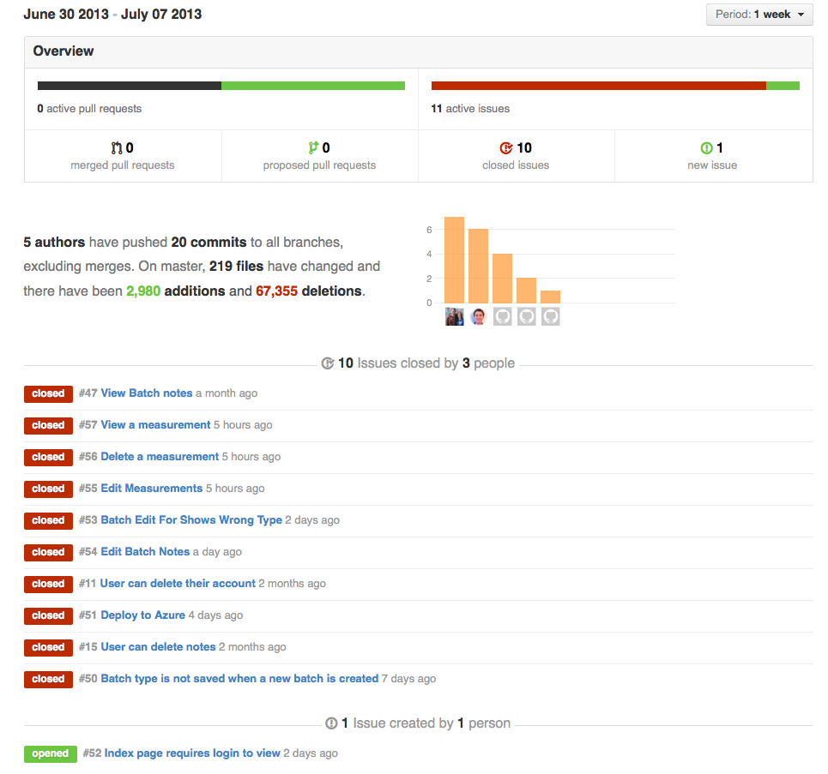

Each of the use cases that were completed this week is shown above. In addition, one new issue was filed this week and has been added to the backlog. All items that were not completed in Sprint 2 have been moved back onto the backlog. They will be reprioritized at the start of Sprint 3. There are currently 23 issues on in the backlog. Some of them have some progress made, but were not completed in time for the Sprint 2 deadline. Most have not yet been started.

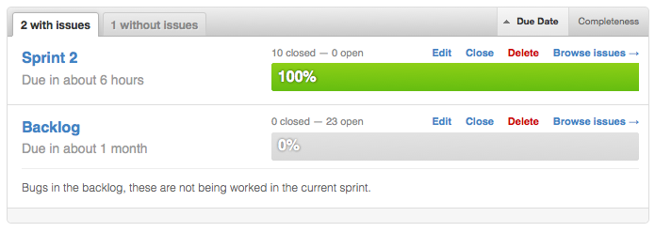

**Test Results (Additional tests related to Sprint 2 Use Cases are in work will be developed in Sprint 3)**

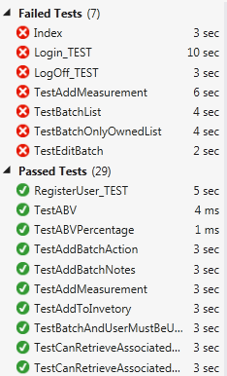

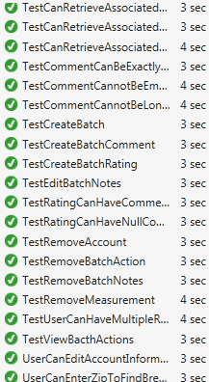

**Sprint Review: Key Functionality**

* 1. **Deployment to Azure**



The deployed system can be seen and used at the URL: <http://homebrew.azurewebsites.net/> this is the production version of the site and is updated with each commit. Anyone can create an account on the site and use the application in its current state.

* 1. **Log-In Return When Trying to Directly Click on Recipes**

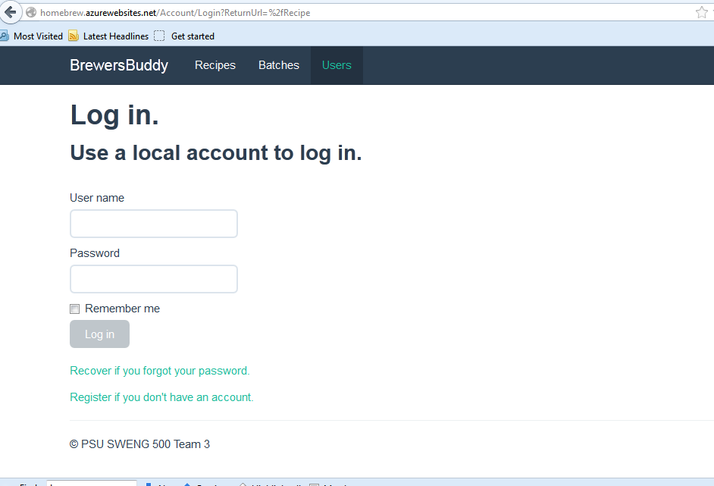

* 1. **UI Refinement**

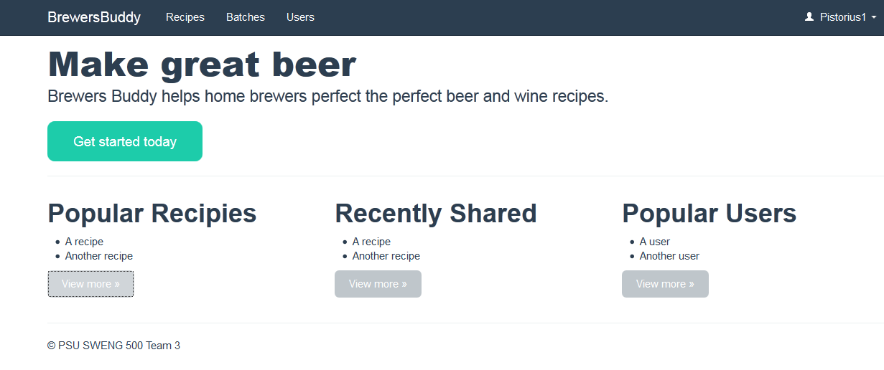

* 1. **Additional UI Refinement**

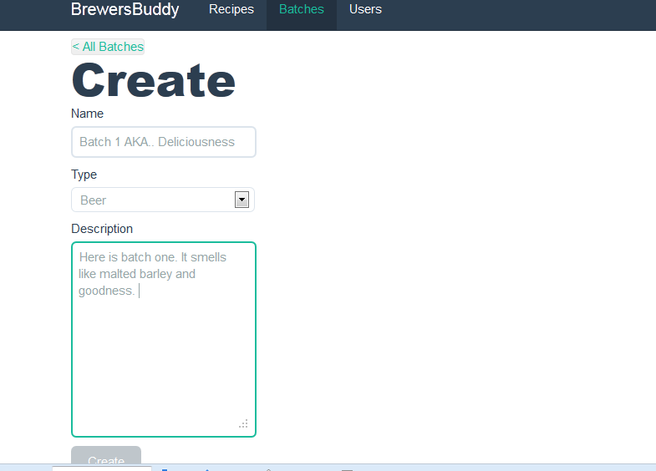

* 1. **Added Measurements and Readings to a Batch**

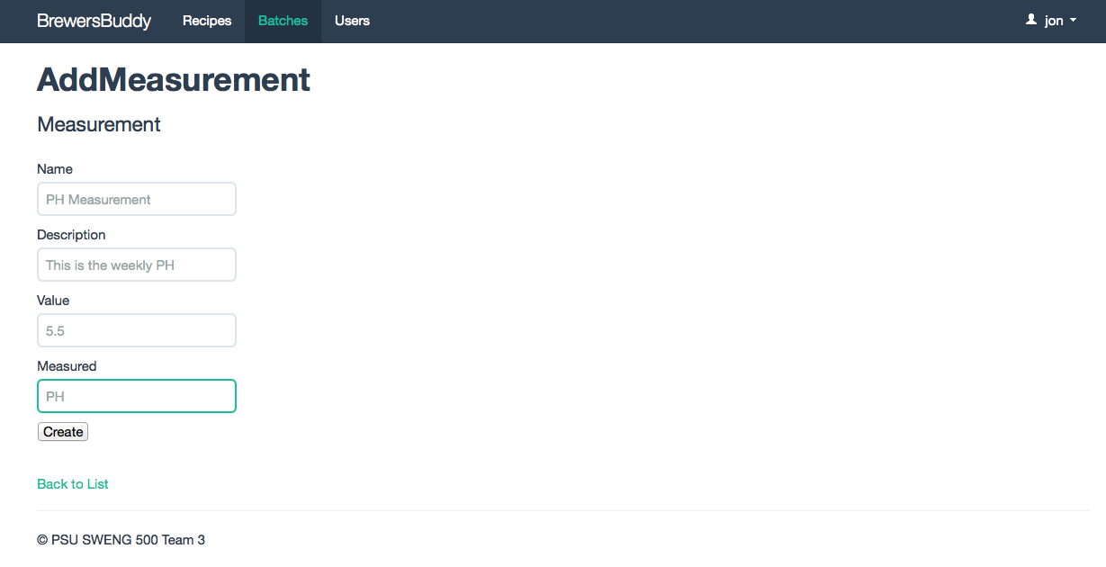

* 1. **User Can Add Notes About a Batch**

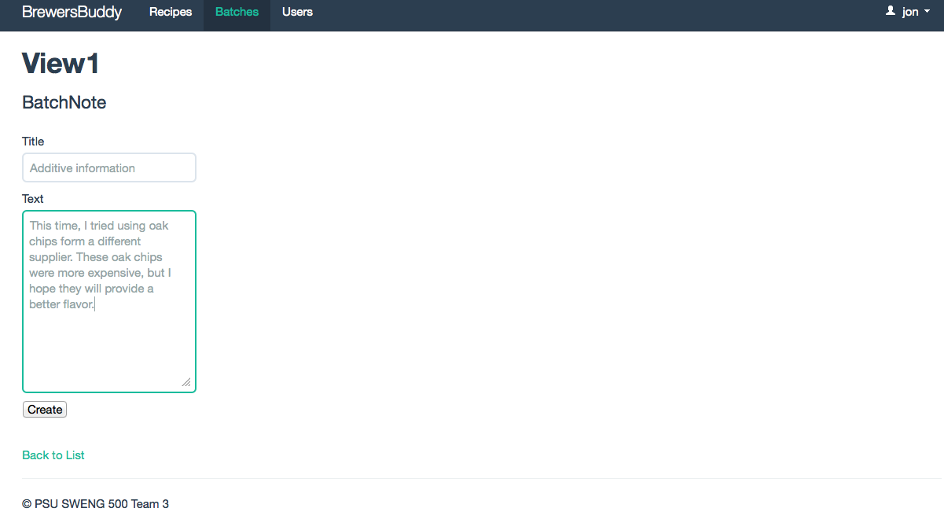

* 1. **User Can Delete a Batch**

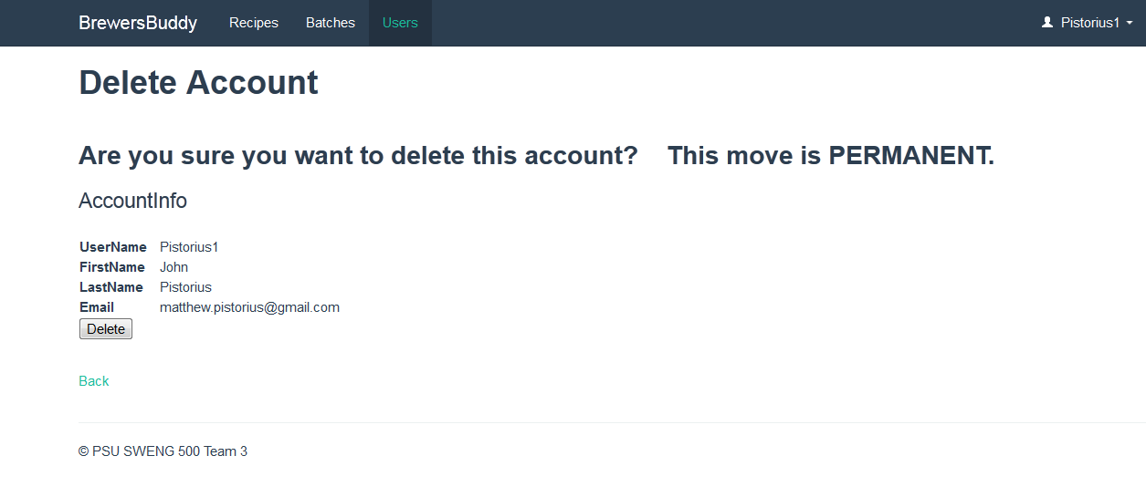

**2. Retrospective**

### What went Well:

1. I think it's good that we're finally getting a consistent UI across the app. The old UI was sort of slapped together and lacked cohesion. I agree that I liked the previous version, but it was becoming too much to maintain and build on and using a pre-rolled theme of sorts means I can focus on programming work and not just UI work.
2. Deployment to Azure.  We need to check if this is an acceptable deployment package for our final submission to PAL.
3. The new UI looks better (Although personally I think Steve's previous version of the new UI looked batter than the latest).
4. I am learning more and being able to contribute more, although most of my work is still based upon how you guys solved similar problems.
5. We deployed to Azure successfully without much trouble.
6. The user interface looks great.
7. We're getting to the point where portions of the product are usable.
8. We're getting better at the ASP MVC framework.

### What could be improved:

1. Communication can be better. It seems like (for me) I have no idea what others are working on and I assume the same can be said of me.
2. Our test coverage seems to be slipping. In my quest to make sure that the main page can be accessible by anyone logged in or not, I failed to include a test. For me, the problem is HOW to test the scenario and not that it should be. I'll be looking more into this this week.
3. I agree our communication will need to improve again these last 5 weeks.
4. Our migration files and database seems to have gotten out conflicted and broken in some way.
5. Gregg is having problems with GitHub.  He is unable to select or deselect assignee, labels, and milestones. We don’t know why this is only happening to him.
6. Team members were busy in their personal lives and the sprint velocity decreased.
7. I really had no idea what anyone else was working on.
8. We still have some key use cases we need to work on.
9. Communication - We haven't met in 2 weeks and other than a few forum posts, we haven't communicated much.
10. Coordination - we really haven't been planning out our goals or direction. It seems like everyone is just picking some random thing to work on. Our efforts are not coordinated.
11. Backlog management - As we move into the final sprint, we will need to make difficult decisions about what is worked on and what is not. Some features will likely slip and not be completed. It is unclear how we are going to make these determinations and prioritize our work. Everyone is working, but I'm not sure we are always working on the right things. This goes back to the coordination issue.

**2.1 What worked well this sprint?**

* Good team communication.
* GitHub and the forum posts do a good job at keeping everyone in the loop in a virtual environment.
* Azure seems to be working well for the team.

## 2.2 What can be improved?

* Work coordination still tough in a 100% virtual environment.
* Now that the Project Management class is over and the holiday is finished we can now pick up the pace for the final sprint.
* Improve on database migration issues.

## 2.3 What still puzzles us?

* Most of us need to continue learning the MVC framework

## 2.4 Additional Accomplishments

* Cleaned up the Add Batch note functionality.
* Added the NSubstitue framework to our project for using Mock objects in unit tests.
* Fixed RemoveBatchNoteTest.
* Mocked frameworks and converted all tests to NUnit from MSTest
* Fix to allow batches with notes to be deleted
* Updated Use Cases & Software Requirements Specification
* Further progress with adding batch actions, but still blocked by a bug.
* Fixed bug in search to not show "No Results when results are shown"
* Added search functionality to Users link (before I knew that it was on backlog)
* Fixed BrewsBuddy link to take user to home page.
* Users can now delete their account
* Added TestRemoveAccount (passes)
* Users can look up friends